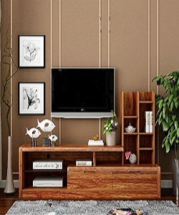

Modern TV Stand

$62.09

Availability: In stock

### Description

Good looking TV stand design with modern wood wall cabinet. The light and fresh design, for storage and TV .this collection create a stylish look that embraces vintage flair and modern living. Complete your living room decor with Style options. Walnut Brown wood finish.